SQL Database and Table Creation

1. Objective
The main purpose of this task is to create the E-Commerce database and construct the Category and Product tables with suitable constraints and relationships.

2. Database Creation
A database named ECommerceDB is created to store and organize the information related to product categories and products.
CREATE DATABASE ECommerceDB;

3. Select the Database
Once the database is created, ECommerceDB is selected so that the required tables can be created inside it.
USE ECommerceDB;

4. Category Table Creation
The Category table is designed to maintain information about the different categories available in the E-Commerce system.
CREATE TABLE Category (

Category_ID INT PRIMARY KEY AUTO_INCREMENT,

Category_Name VARCHAR(50) NOT NULL UNIQUE,

Description VARCHAR(200)

);

Attributes
Attribute | Data Type | Constraint | Description
Category_ID | INT | Primary Key, Auto Increment | Provides a unique identifier for each category
Category_Name | VARCHAR(50) | NOT NULL, UNIQUE | Stores the name of the category
Description | VARCHAR(200) | — | Contains a brief description of the category

5. Product Table Creation
The Product table is created to store important product information, including product name, category, price, and available stock.
CREATE TABLE Product (

Product_ID INT PRIMARY KEY AUTO_INCREMENT,

Product_Name VARCHAR(100) NOT NULL,

Category_ID INT NOT NULL,

Price DECIMAL(10,2) NOT NULL CHECK (Price > 0),

Stock_Quantity INT NOT NULL DEFAULT 0 CHECK (Stock_Quantity >= 0),

CONSTRAINT fk_product_category

FOREIGN KEY (Category_ID) REFERENCES Category(Category_ID)

ON UPDATE CASCADE

ON DELETE RESTRICT

);

Attributes
Attribute | Data Type | Constraint | Description
Product_ID | INT | Primary Key, Auto Increment | Provides a unique identifier for each product
Product_Name | VARCHAR(100) | NOT NULL | Stores the name of the product
Category_ID | INT | Foreign Key, NOT NULL | Associates the product with its category
Price | DECIMAL(10,2) | NOT NULL, CHECK | Stores the price of the product
Stock_Quantity | INT | NOT NULL, DEFAULT, CHECK | Represents the quantity of products available in stock
The table structure and constraints follow the requirements of the Week 2 Product and Category Management System.

6.Constraints Used
The following constraints are applied to maintain the accuracy and integrity of the database:
- Primary Key (PK): Provides a unique identification for every record.
- Foreign Key (FK): Establishes a connection between the Product and Category tables.
- NOT NULL: Ensures that required fields cannot contain empty values.
- UNIQUE: Ensures that category names are not repeated.
- CHECK: Validates the price and stock quantity values.
- AUTO_INCREMENT: Automatically generates a unique ID for new records.
- DEFAULT: Assigns a stock quantity of 0 when no value is specified.
These constraints are defined in the table creation script.

7. Relationship

Category → Product
The Category and Product tables are connected through the Category_ID field.
- A single category can contain multiple products.
- Each product is associated with one category.
Relationship: One-to-Many (1 : Many)
This relationship is implemented using the foreign key Category_ID in the Product table.

8. Verification
The following SQL commands can be used to confirm that the database tables have been created correctly.

Display Available Tables
SHOW TABLES;
Screenshot:
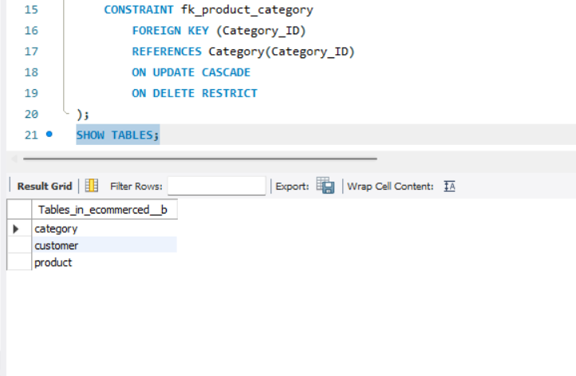Check Category Table Structure
DESC Category;
Screenshot:
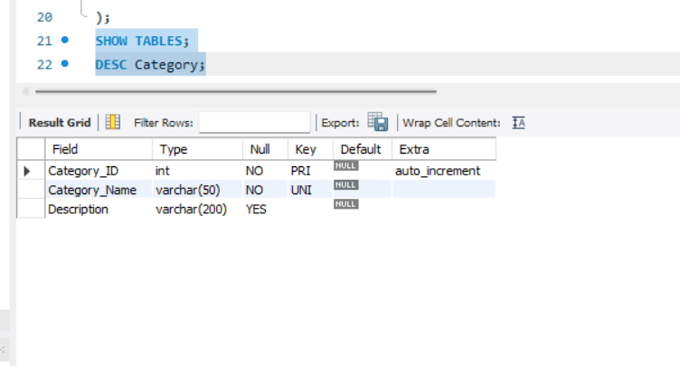Check Product Table Structure
DESC Product;
Screenshot:
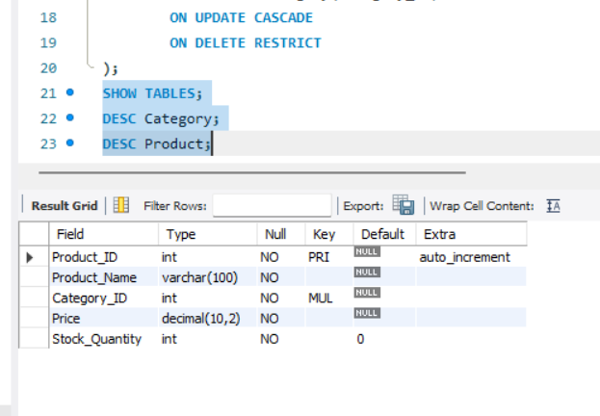

9. Final Result
The ECommerceDB database was successfully created along with the Category and Product tables. Appropriate constraints such as Primary Key, Foreign Key, NOT NULL, UNIQUE, CHECK, AUTO_INCREMENT, and DEFAULT were implemented. The relationship between the Category and Product tables was also established successfully.

